LAB 6: CODE & BRANCH COVERAGE ANALYSIS
Salon Booking Application

Objective
To run the automated test cases for the salon booking application and inspect the statement/code coverage and branch coverage report generated using pytest and coverage.py.

1. Code Coverage
Command used: python -m coverage report -m salon_booking.py
The captured report shows 37 statements, 0 missed statements, and 100% coverage.
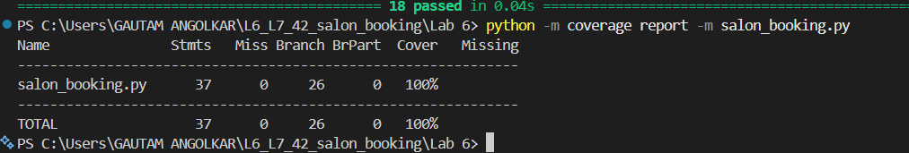

2. Branch Coverage
Commands used:
python -m coverage run --branch -m pytest -v BranchCoverageTest_42_salon_booking.py
python -m coverage report -m salon_booking.py
The captured report shows 37 statements, 0 missed statements, 26 branches, 0 partial branches, and 100% coverage.

Conclusion
Based on the screenshots provided, all 18 tests passed. The coverage report shows 100% coverage for salon_booking.py, with no missed statements and no partially covered branches in the branch-enabled run.

